What can help to differentiate between the normal septal q wave and a pathologic Q wave?
Top of Form
 A. The width
B. The height
C. Both width and height
D. The QRS axis
E. The specific ECG leads involved

Bottom of Form
In an acute Q-wave MI, which ECG finding is usually the first to appear?
Top of Form
A. Q wave
B. Hyperacute T wave
C. T wave inversion
D. ST segment elevation
E. None of the above

What is the correct diagnosis of this ECG?
Top of Form
A. Anterolateral MI
B. High lateral MI
C. True posterior MI
D. Inferolateral MI
E. Inferior MI
Bottom of Form

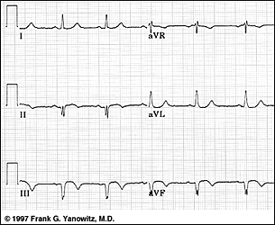

What is the correct diagnosis of this ECG?
Top of Form  Bottom of Form | A. Anteroseptal MI
 | B. Anterior MI
 | C. Posterior MI
 | D. Posterolateral MI
E. Right ventricular MI
Bottom of Form

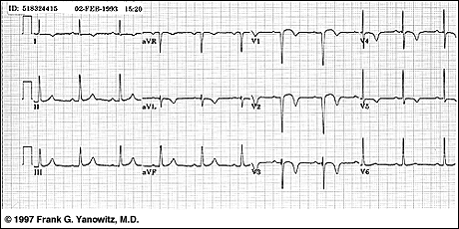

What is the correct diagnosis of this ECG?
Top of Form  Bottom of Form | A. True posterior MI
 | B. Extensive Anterior/Anterolateral MI
 | C. Inferoposterior MI
 | D. Posterolateral MI
E. Posterolateral MI + LBBB
Bottom of Form

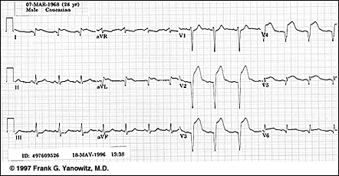Bottom of Form

What is the correct diagnosis of this ECG?
Top of Form  Bottom of Form | A. Inferior MI
 | B. Posterior MI
 | C. Inferoposterior MI
 | D. Anterior MI
E. Non-Q wave MI
Bottom of Form
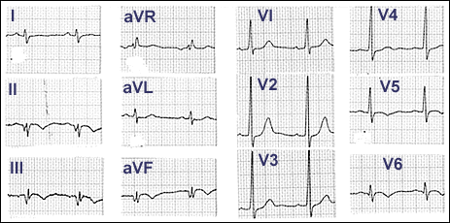

Mrs Morgan is bought to casualty by her daughter with chest heaviness and nausea. She is 84 years old and has had diabetes for 15 years controlled by oral medications. On examination she has a jugular venous pressure 3cm above the sternal notch. There is a murmer of mitral regurgitation and no pulmonary crackles. Her ECG is shown .
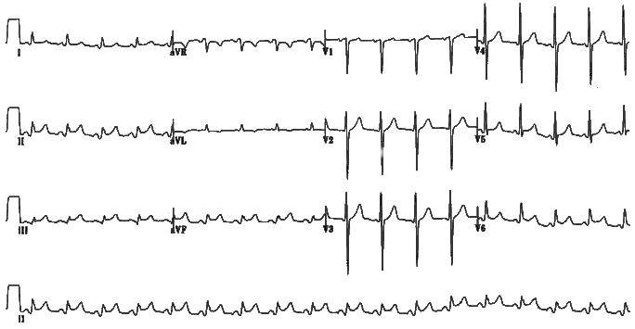

A 60-year-old "walk-in" patient without a primary care physician arrives at your clinic near the end of a busy afternoon clinic session. The patient is not on any medications and has not seen a physician in years. The patient complains of several hours of severe chest pressure and as he lives nearby he thought he would come to your clinic and try to see a physician. Although the vital signs were remarkable only for some bradycardia, the medical assistant is concerned that the patient appears ill. A stat ecg was done and you are asked to see this patient immediately. The following ecg is handed to you as you are on your way to see this patient.
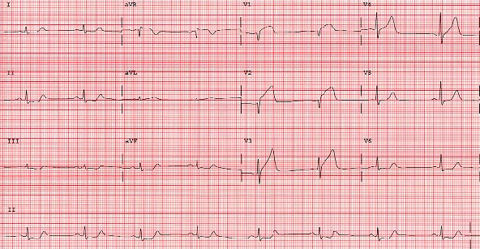
acute injury pattern of ST elevation noted in V1-V4

A 55-year-old patient comes in to get your advice on starting a new exercise program to get back into shape. The program involves heavy aerobic workouts and he needs a form filled out that he is medically cleared to participate in this workout program. In talking to him you learn he has cardiac risk factors for smoking, positive family history, high cholesterol and hypertension. He has a sedentary lifestyle and has not participated in any strenuous physical activity for years. Although his cardiorespiratory review of systems is negative, you are concerned that his activity level is very limited and he has significant risk factors. As part of the workup you obtain the following ecg to interpret:
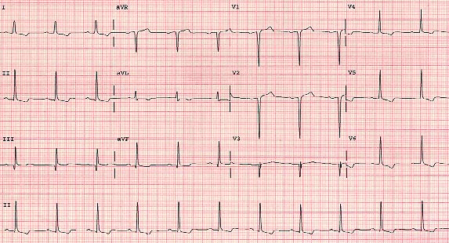
first degree block_LVH Q waves noted in V2 and V3old MI

A 76-year-old patient, with a history of hypertension, comes to see you. She is currently on a diuretic prescription and is complaining of a few days of "skipped heart beats". She has felt slightly dizzy lately but does not have any other symptoms. Overall she has been feeling well, her only medical issue has been hypertension. Previous electrocardiograms in her chart show normal sinus rhythm and are otherwise unremarkable. Her exam shows an irregular pulse in the 130 rate range but the rest of the exam is unremarkable. You obtain the following electrocardiogram:
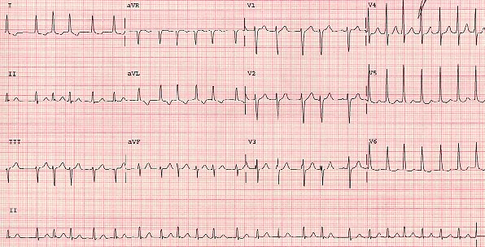
atrial fibrillation
A 35-year-old man comes into your office as a new patient. He is concerned about his elevated blood pressure. A year ago, in a physicians office, he had a reading of 150/100. A month ago, while being evaluated for bronchitis at a walk-in clinic, his blood pressure was 150/105. At today's office visit his blood pressure is 155/105. He is asymptomatic and currently takes no medications. His cardiac exam is remarkable for a laterally displaced PMI and an S4. As part of the workup, you obtain the following electrocardiogram:
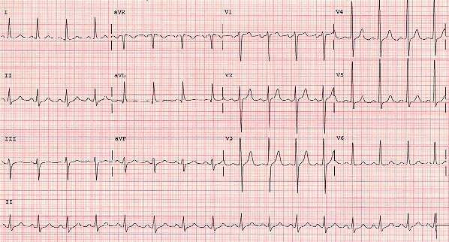
HTN+LVH
A 65-year-old, female patient comes in for a get acquainted visit. She has a history of severe chronic obstructive pulmonary disease and is on multiple medications and home oxygen. During the physical she is noted to be tachycardic with an irregularly irregular pulse. An electrocardiogram is taken for further evaluation.
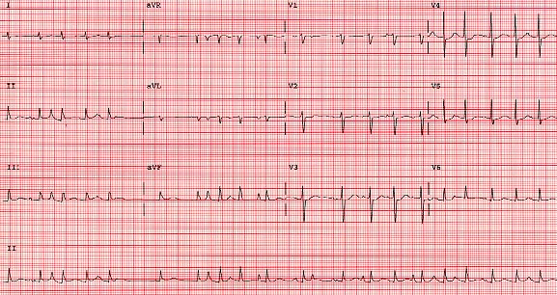
multifocal atrial tachycardia

1) A nineteen-year-old male with a history of recurrent palpitations presents to the emergency room. He complains of palpitations and lightheadedness. This ECG is recorded:
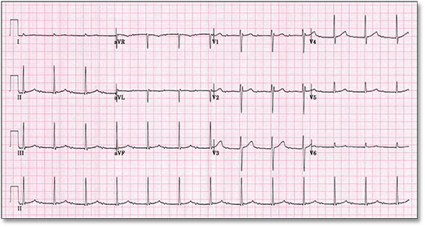
atrial rate is 150 and the ventricular rate is 75 BPM.
While the emergency room physician was pondering these very questions, the nurse rushed in with a second ECG:
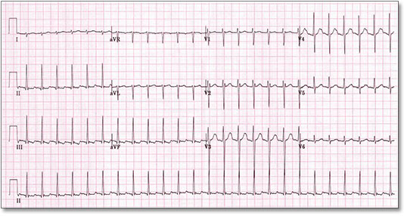
- Atrial tachycardia
- Atrioventricular reentrant tachycardia (AVRT, accessory pathway mediated)
- Atrioventricular nodal reentrant tachycardia (AVNRT)
Adenosine was administered, and sinus rhythm was restored:
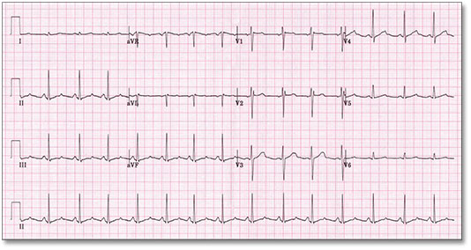
2) A sixty-seven-year-old female undergoes pacemaker implantation for the tachycardia-bradycardia syndrome. The procedure is uncomplicated. She is observed overnight, and the following morning, this ECG is recorded:
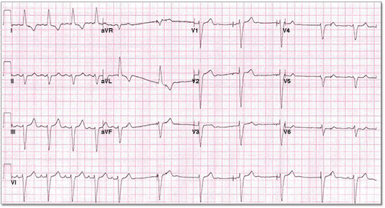
3) A 21-year-old male with a prior history of repaired congenital heart disease (transposition of the great vessels, s/p Senning procedure) presents to the emergency room with palpitations and lightheadedness. The heart rate is 200 BPM, and blood pressure is 105/65. His ECG:
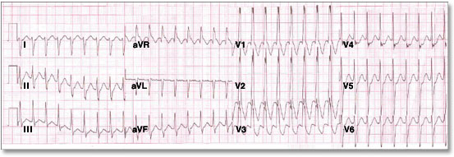
An IV is inserted, and while IV fluid is administered, this ECG is recorded:
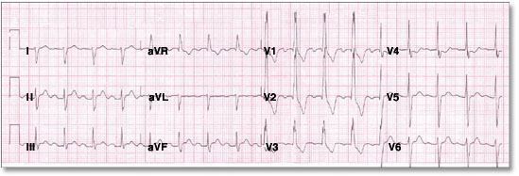

After ikacore
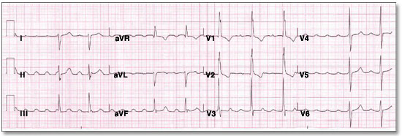

4) A sixty-nine-year-old female presents to the emergency department with symptoms of palpitations and near syncope. She has a history of rheumatic heart disease, and has had prior mitral valve replacement, bypass grafting, and pacemaker implantation. Systolic blood pressure is 90 by palpation. Her rhythm strip follows:
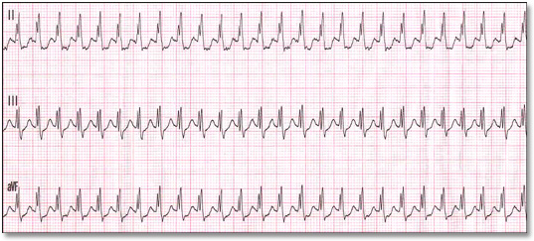
after amiodarone